43, Baumoe-ro 41-gil, Seocho-gu, Seoul, Republic of Korea (Yangjae-dong, Focus Building 2F) Charge: Bo-Gyu Park
Tel: 82-2-554-3161 Fax: 82-2-556-3161, Homepage http://ecmu.net, E-mail: say0426@naver.com

Article No: 17-0701
Effective date: July 19, 2017
Reception: Animal rights activist
Reference: Assistant
Title: International Forum for Declaration of Animal Love by S. Korean Youth

To whom it may concern,
A. We start by wishing your organization flourish;
B. E.C.M.U. is an official non-governmental organization(NGO) for international development. We are carrying out projects for environmental protection and life respect by educating the young generation.
C. We are actively supporting activities for animal protection done by South Korean youth. We therefore demand your support, and invite your group and animal protection activists to the International Forum for Korean animal law enactment.

Information
a. Title: International Forum for Declaration of Animal Love by S. Korean Youth
b. Host: Korea Animal Protection Youth Volunteer Group
c. Sponsor: Association of Earth Preservation Movement Association, The Voice of Animals
d. Date:
- Declaration of Animal Protection Charter, August 8, 2017
- Animal Protection Measure Seminar: September 9, 2017
- International Forum (Animal Protection), October 10, 2017
- International Forum for Enactment of Animal Law, November 11, 2017
- Resolution Conference for Enactment of Animal Law, December 12, 2017
e. Purpose and Projected Effects
(1) To hold a forum for constituting regulations on the prohibition of dog meat in S. Korea
(2) To enhance the level of animal protection and animal welfare in S. Korea through
international forums
(3) To provide the opportunity for Korean youth to participate in the animal protection campaign as a global citizen
f. Goal: Participation and support for amendment of dog meat prohibition law of S. Korea
g. Contact: Bo-Gyu Park / Cell Phone 82-10-5645-6113, Phone 82-70-4799-1004

.

Ministry of Environment Permit No. 491 www.ecmu.net
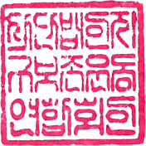
Incorporated Association Jigubozon

International Forum for Declaration of Animal Love by S. Korean Youth

Declaration of Animal Love by S. Korean Youth is an international forum for life respect led by E.C.M.U. We would like to support S. Korean youth who would be the next global leader by enhancing their ability for international exchange and fostering their active participation. E.C.M.U., as an NGO for international development, have been running many businesses to practice environmental protection and life respect through education. As a request of life respect and animal love by youth, we are hosting an international forum with hope to improve animal protection law and animal welfare in South Korea. This is an opportunity for S. Korean youth to work as a global citizen and to explore the scene of international exchange.

Summary
- Title: International Forum for Declaration of Animal Love by S. Korean Youth
- Topic: Animal protection, respect for life and discussion for enactment of animal law.
- Participant: Secondary school students
- Number of people: 300
- Event period: June 15, 2017 ~ December 31, 2017
- Host: Korea Animal Protection Youth Volunteer Group
- Sponsor: Association of Earth Preservation Movement Association, The Voice of Animals
- Email: kpen@naver.com

Schedule

- Declaration of Animal Protection Charter, August 8, 2017
Location: 23, Dogok-ro 77-gil, Gangnam-gu, Seoul, Republic of Korea
- Animal Protection Measure Seminar: September 9, 2017
Location: 1, Uisadang-daero, Yeongdeungpo-gu, Seoul, Republic of Korea
- International Forum (Animal Protection), October 10, 2017
Location: 1, Uisadang-daero, Yeongdeungpo-gu, Seoul, Republic of Korea
- International Forum for Enactment of Animal Law, November 11, 2017
Location: 1, Uisadang-daero, Yeongdeungpo-gu, Seoul, Republic of Korea
- Resolution Conference for Enactment of Animal Law, December 12, 2017
Location: 1, Uisadang-daero, Yeongdeungpo-gu, Seoul, Republic of Korea

Korea's Animal Protection and Efforts for Anti dog meat law

1. Earth Preservation Movement Association "Looking for a new family of rescued dogs"
http://www.segye.com/newsView/20170613002629
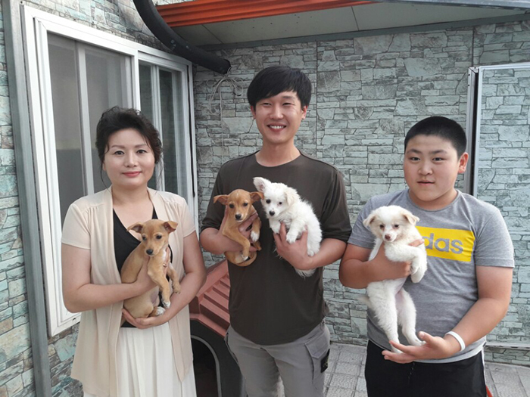

2. Save 39 dogs from the death by slaughter crisis
http://www.an.or.kr/news_gisa/gisa_view.htm?gisa_idx=7318
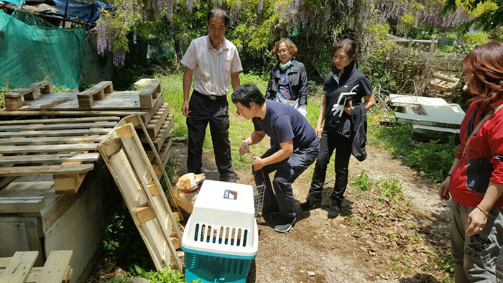

3. National animal protection activists demand 'animal protection policy' from ruling party.
http://news1.kr/articles/?3013998
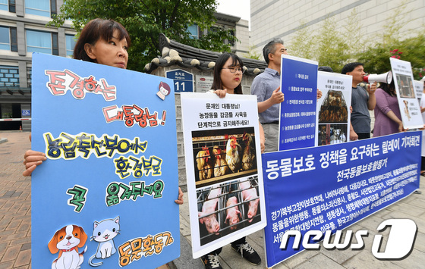

4. "Let's not eat dogs" HSI, campaign to stop dog meat ahead of -Chobok.
http://news1.kr/articles/?3033081
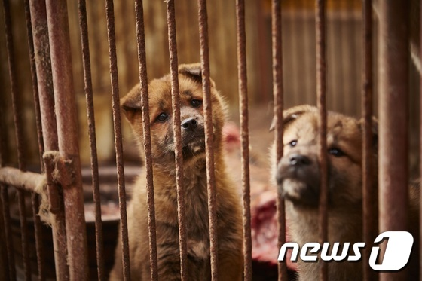

5. "Please adopt step-by-step prohibition of dog meat"
http://www.fnnews.com/news/201705081714294861
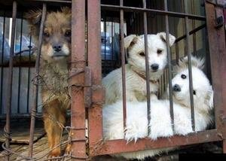

6. Let's make special laws of ban slaughtering dogs and cats.
http://news1.kr/articles/?2959908
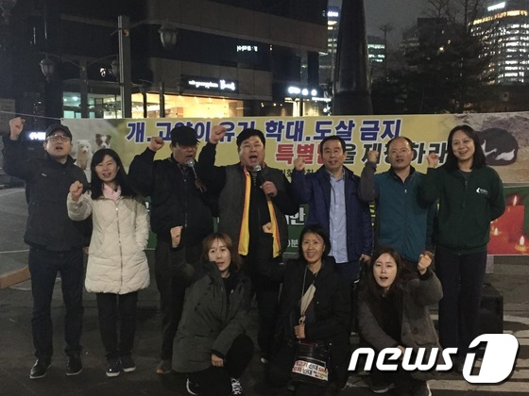

7. Respect for the lives of Korean youth, participation in animal protection activities

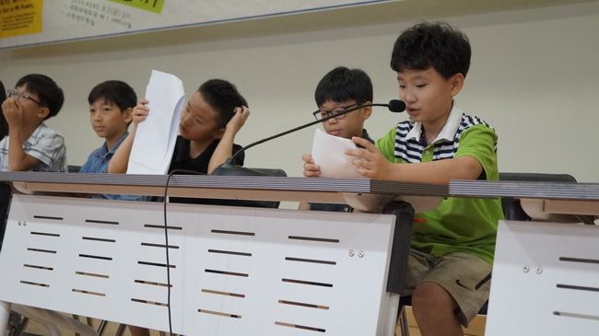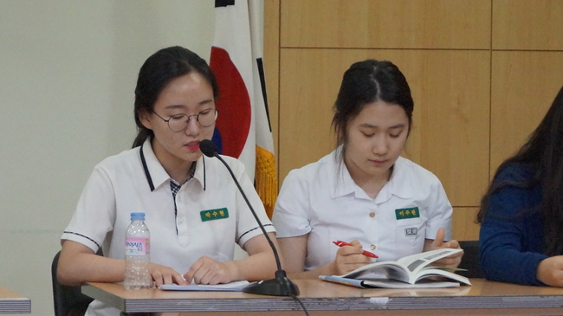

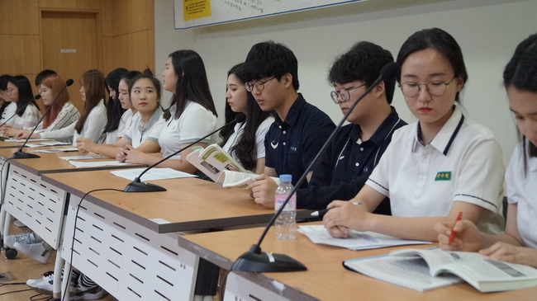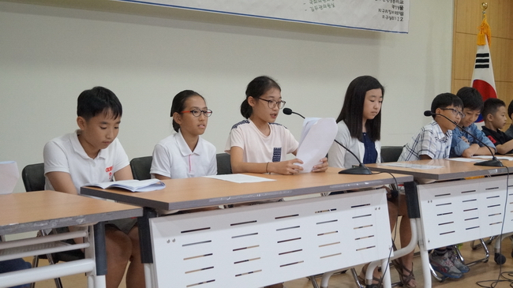

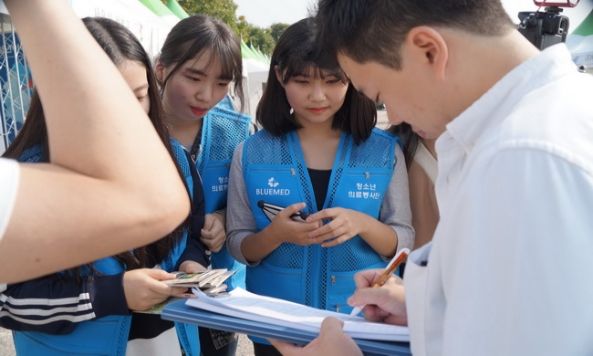

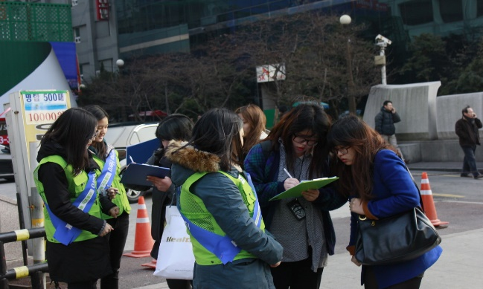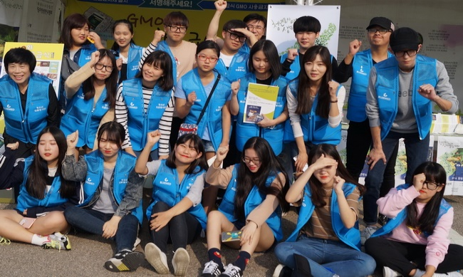

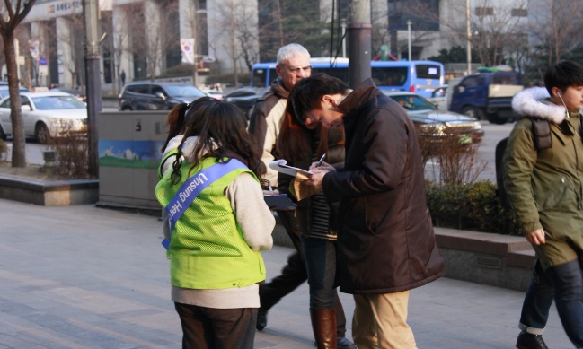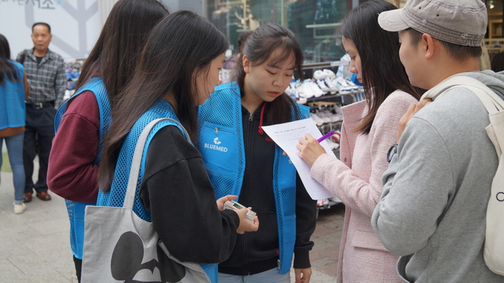
"On October 10, youths invite you to the International Forum on No dog meat."
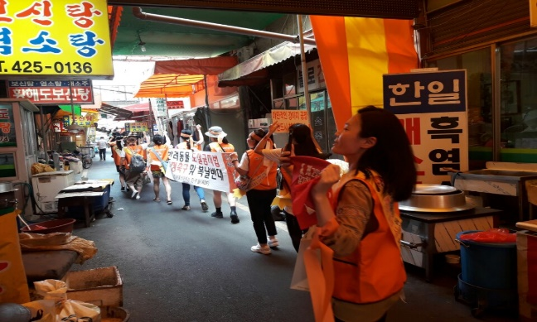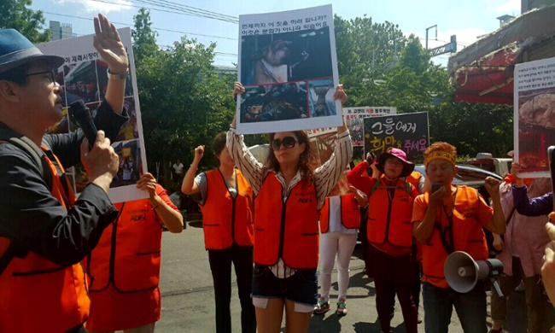
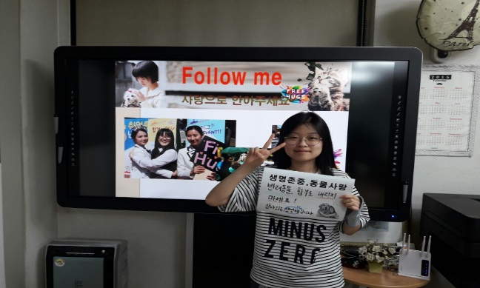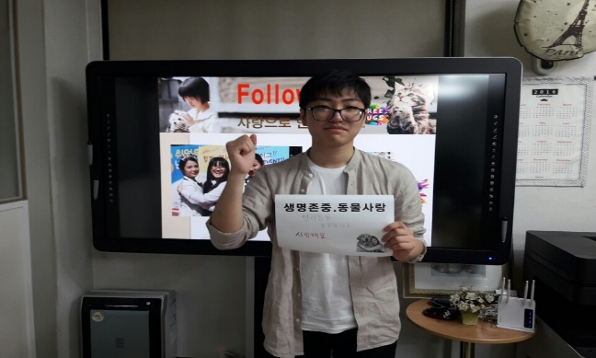
Respect Life, Love Animal Respect Life, Love Animal
Don’t throw away pets. They are living creatures.
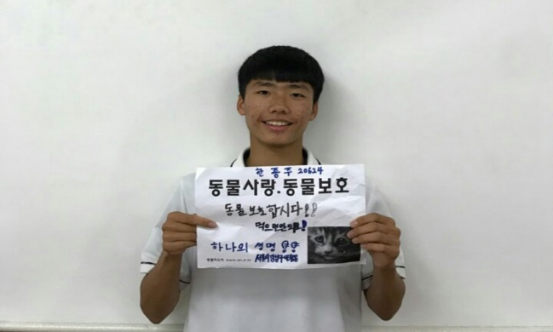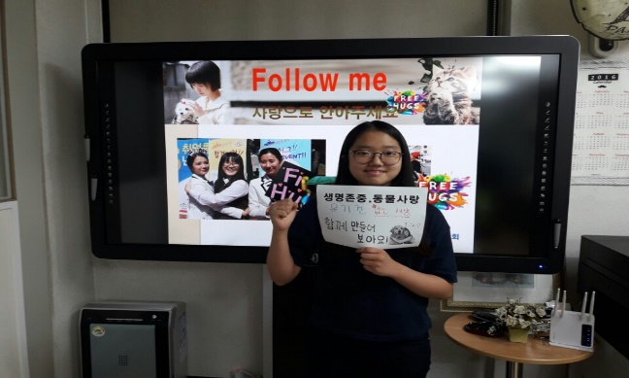
Love Animal, Protect Animal Respect Life, Love Animal
Don’t eat pets. Let’s make the world without homeless dogs.
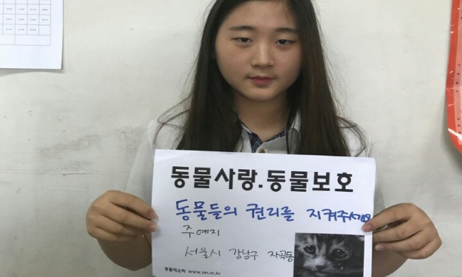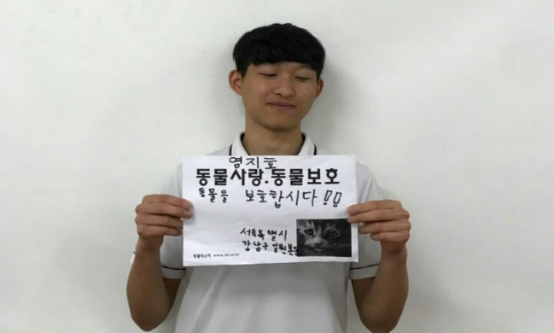
Love Animal, Protect Animal Love Animal, Protect Animal
Defend pet’s rights.
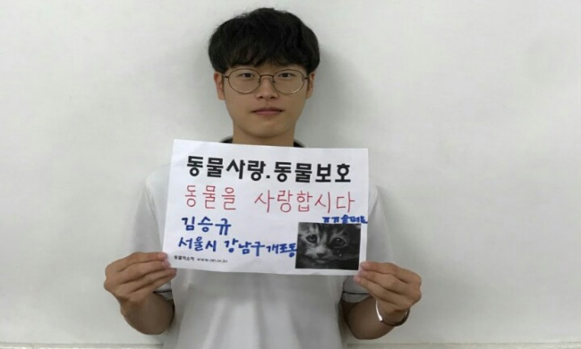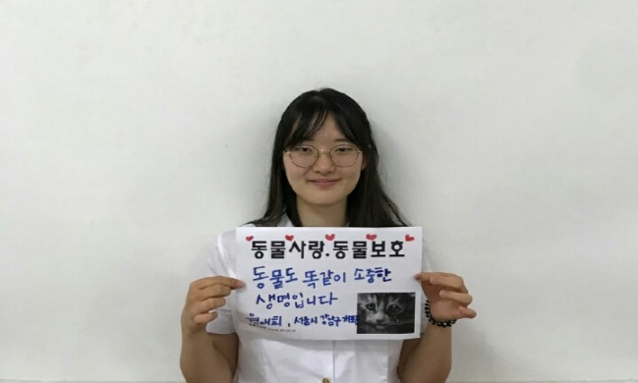
Love Animal, Protect Animal Love Animal, Protect Animal
They are precious lives the same as human.
"Send a message of love to Korean youths so that animal protection laws can be enacted"

Animal Protection Statement of S. Korean Youth
We want
Animals to live a happy life with us.
We want
Animals to have a better life in Korea.
We want
Animals to be treated as our family members.

S. Koreans have been eating dog meat from the past, and this bad habit has not disappeared. In the global era, the dog meat has been banned in almost all countries along with desires for animal protection; however, countries such as Korea, China, Vietnam, and Philippines have not yet reached this level.

In Korea, too, many people are trying to change these immoral practices by taking the importance of protecting animals. In response to this global animal protection movement, Korean youths, who will be the protagonists of this country, are eager to fix these bad practices.

2.5 million dogs are slaughtered annually for a meal in S. Korea, and each year 6 million dogs suffer from animal testing in the world.

Animals are not for human, nor for experiment. They are the living creatures that we should respect.
However, this country who is obliged to protect them denies their duty.
Adults who are supposed to be the leaders are turning their back.

To all adults around the world, Korean youths demand for a global community where everyone respects life. We would like to ask for your support so thus accomplish our goal. Please send cheer letters and messages to help us fulfill our desires.

Dear President Moon, who leads Korea to a better place to live!
You are the first leader who have adopted the abandoned dog in the Blue House.
We want your active support that you promised during the days of the candidate. In that way, we will finally be able to reach mature civic consciousness.

Animal protection and human protection are not separable matters.
Korean youths want a joyful future with animals.

Please provide a place of respect for life for the future of our generation.
Please prepare a place where animals can be protected for the future of our generation.

From desires of Korean youth, Park Jong-hoon (2nd grade in Sejong High School) and 120 youths;

* Bong Eun Middle School (Jung Jae Won, Kim Hyeong Wook), Gaewon Middle School (Hwang Yoo Jin), Daechung Middle School (Mun Sik Hwan), Gopo High School (Juyeji, Won Jae Hee, Sejong High School (Park Jung Hoon, Kang Ju Hyun, Kim Ji Soo, Kim Tae Eun, Jung Dae Eun), Sookmyung Girls' High School (Lee Yewon, Choi In-Won), Tongdae Affiliated High School (Lee Eun Jong, Park Jung Ho), Seojong High School (Park Jung Hoon, Kang Ju Hyun, Kim Ji Soo, Kim Tae Eun, Jung Dae Eun) ...

